OPERATING SYSTEM
OUTPUTS :
PROGRAM 1 :
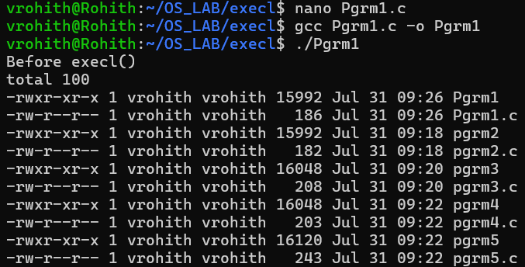

PROGRAM 2 :
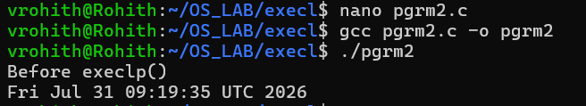
PROGRAM 3 :
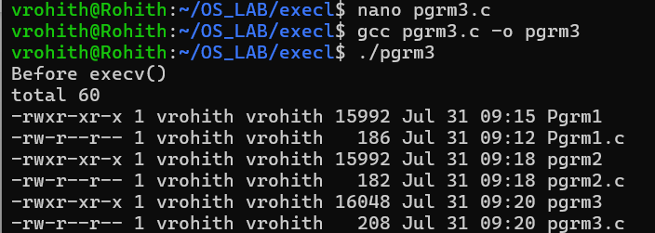
PROGRAM 4 :
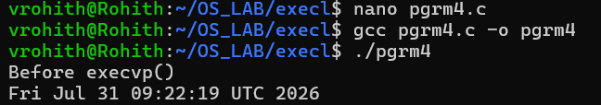

PROGRAM 5 :
